2014年苏州市初中结业考试题及答案（地理）

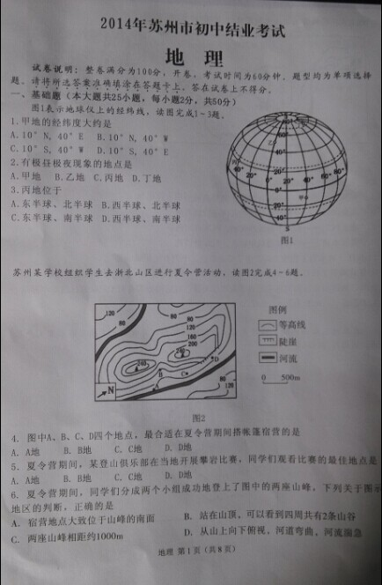

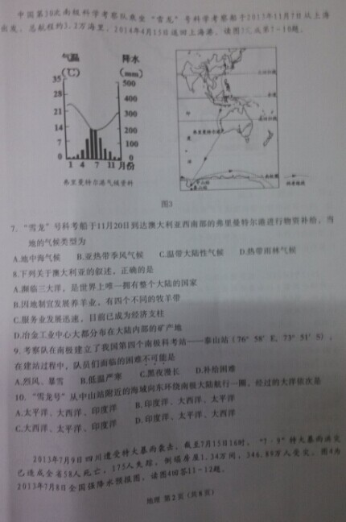

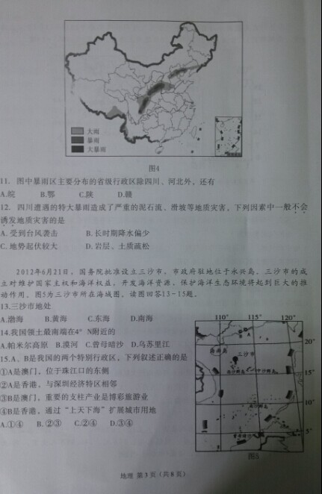
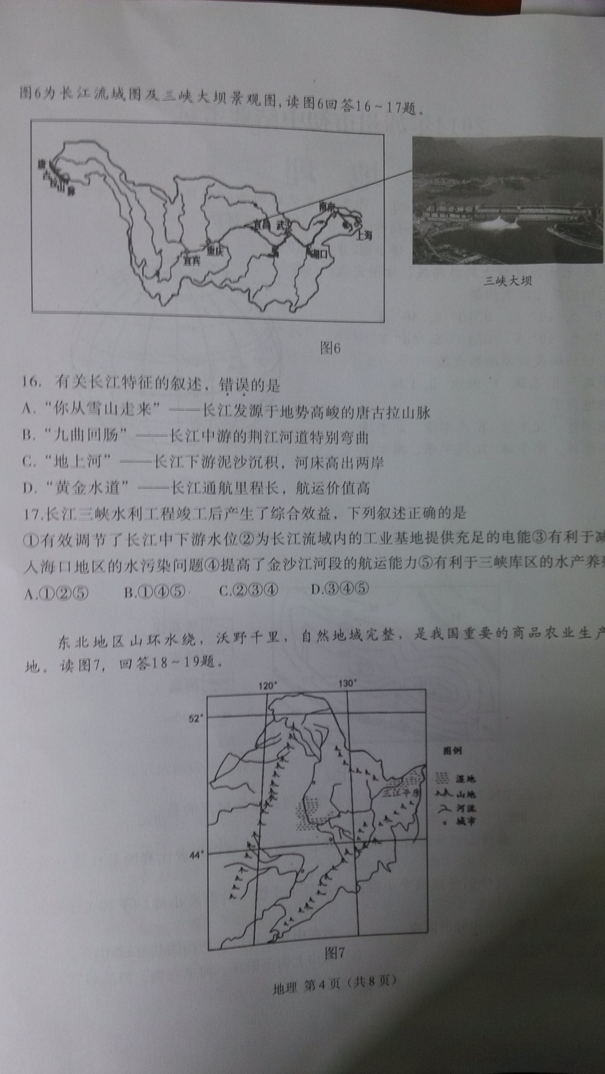
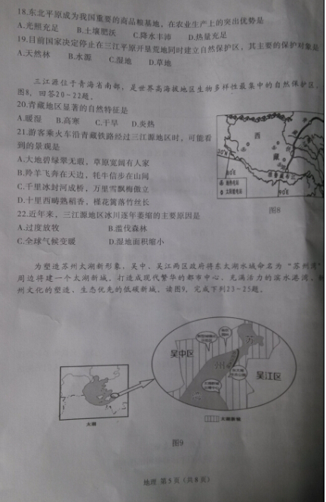

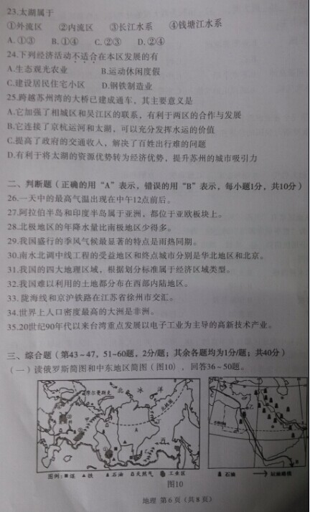
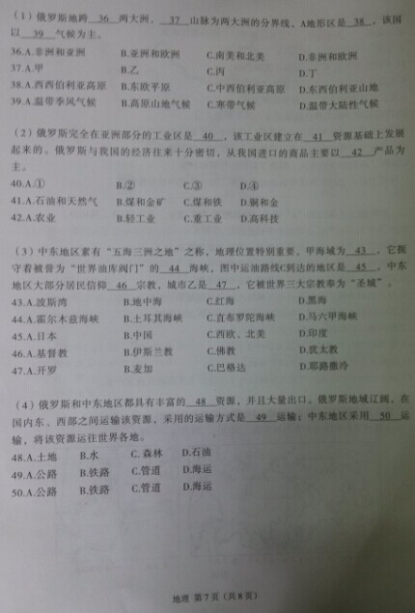
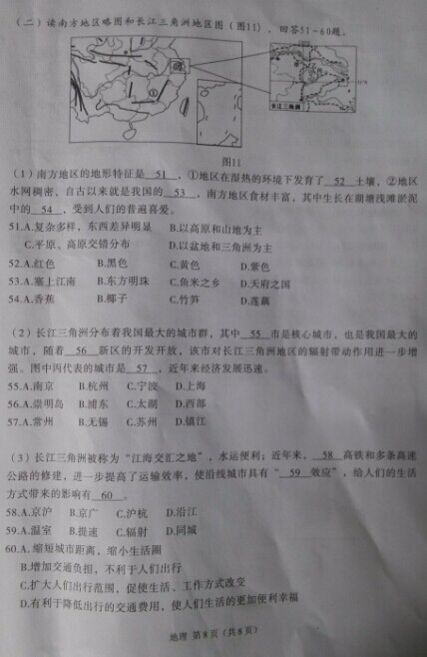

2014年苏州市初中结业考试地理参考答案
1 | 2 | 3 | 4 | 5 | 6 | 7 | 8 | 9 | 10
D | D | B | C | D | C | A | C | C | D
11 | 12 | 13 | 14 | 15 | 16 | 17 | 18 | 19 | 20
C | B | D | C | B | C | A | B | C | B
21 | 22 | 23 | 24 | 25 | 26 | 27 | 28 | 29 | 30
B | C | A | D | D | B | B | B | A | A
31 | 32 | 33 | 34 | 35 | 36 | 37 | 38 | 39 | 40
B | B | A | B | A | B | A | C | D | A
41 | 42 | 43 | 44 | 45 | 46 | 47 | 48 | 49 | 50
C | B | A | A | C | B | D | D | C | D
51 | 52 | 53 | 54 | 55 | 56 | 57 | 58 | 59 | 60
A | A | C | D | D | B | C | C | D | C

